**Problem 1**

Program:

Result:

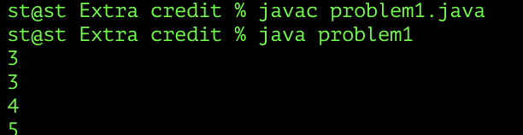

**Problem 2**

Program:

Result:

**Problem 3**

Program:

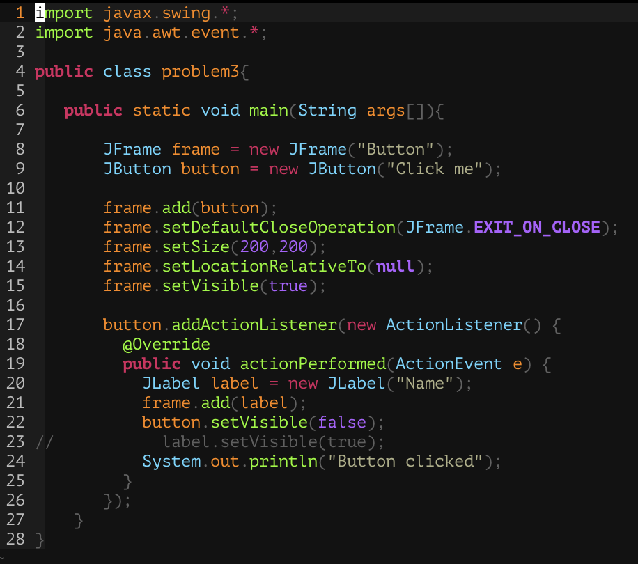

Result:

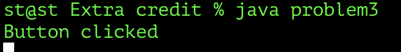

After click 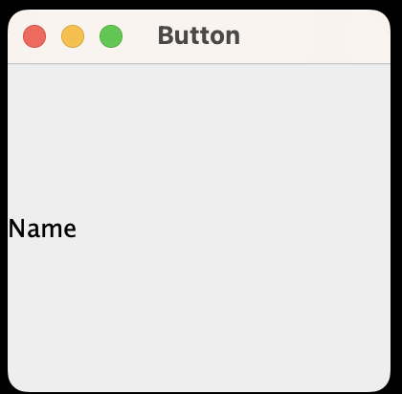

**Problem 4**

Program:

Result:

